CMSC 204

Huffman Lab

1. Create a Huffman Tree and generate the codes for each character of the following input:

create a huffman tree

For consistency:

1. If same frequency – put in priority queue alphabetically; put space before other characters of the same frequency
2. Add subtrees to end of group with same priority
3. Lower number has higher priority (goes to front)

|  |  |
| --- | --- |
| “create a huffman tree” | # of Frequency |
| c | 1 |
| r | 2 |
| e | 4 |
| a | 3 |
| t | 2 |
| h | 1 |
| u | 1 |
| m | 1 |
| n | 1 |
| f | 2 |
| “_” | 3 |

|  |  |
| --- | --- |
| Priority queue alphabetically | Same # of Frequency |
| c  h  m  n  u | 1  1  1  1  1 |
| f  r  t | 2  2  2 |
| “_”  a  e | 3  3  4 |

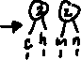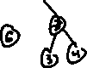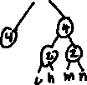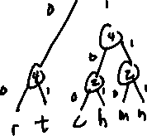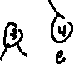

Now encode “create a huffman tree”

|  |  |  |  |  |  |  |  |  |  |  |  |  |  |  |  |  |  |  |  |  |
| --- | --- | --- | --- | --- | --- | --- | --- | --- | --- | --- | --- | --- | --- | --- | --- | --- | --- | --- | --- | --- |
| c | r | e | a | t | e |  | a |  | h | u | f | f | m | a | n |  | t | r | e | e |
| 0100 | 000 | 111 | 101 | 001 | 111 | 100 | 101 | 100 | 0101 | 1100 | 1101 | 1101 | 0111 | 101 | 0110 | 100 | 001 | 000 | 111 | 111 |

1. Based on the following Huffman tree and binary sequence, what is the text

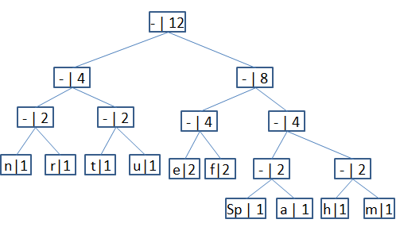



1110|011|101|101|1111|1101|000|1100|010|001|100|100

